**MILESTONE 3**

**Project : Financial Sample Dashboard**

### ****1. Introduction****

#### ****1.1 Purpose of the Dashboard****

The dashboard aims to provide an in-depth analysis of financial performance across multiple dimensions such as regions, categories, and time periods. It is designed for executive decision-makers to identify trends, optimize resources, and evaluate key performance indicators (KPIs) for business growth.

#### ****1.2 Dataset Overview****

The dataset contains transactional records from 2018 to 2023, including over 50,000 entries. Key columns include Sales Amount, Profit, Category, Region, and Date, allowing for robust analysis of business performance across various dimensions.

#### ****1.3 Key Features****

* Interactive visualizations for better insights.
* Dynamic filtering and cross-highlighting.
* Real-time updates (if applicable).

### ****2. DAX Functions****

### ****1. Aggregate Functions****

#### ****1.1 Total Sales****

* **Purpose**: Calculates the total revenue generated from sales.

Total Sales = SUM(Sales[Amount])

* **Explanation**:
  + The SUM function adds up all the values in the Amount column of the Sales table.
  + Used in KPI cards, bar charts, or trend analyses.

#### ****1.2 Total Profit****

* **Purpose**: Computes the overall profit by summing up the profit column.

Total Profit = SUM(Sales[Profit])

* **Explanation**: Similar to Total Sales but applied to the Profit column.

### ****2. Ratio and Percentage Calculations****

#### ****2.1 Profit Margin****

* **Purpose**: Calculates profit as a percentage of sales.

Profit Margin = DIVIDE(SUM(Sales[Profit]), SUM(Sales[Amount]), 0)

* **Explanation**:
  + The DIVIDE function divides the total profit by the total sales.
  + The third argument 0 ensures no errors occur if sales are zero.
  + Displayed in KPI cards or visualizations for profitability analysis.

#### ****2.2 Contribution to Total Sales****

* **Purpose**: Computes the percentage contribution of each category/region to total sales.

Sales Contribution = DIVIDE(Sales[Amount], CALCULATE(SUM(Sales[Amount]), ALL(Sales)))

* **Explanation**:
  + CALCULATE evaluates the total sales across all categories by removing filters using ALL.
  + Helps in identifying the share of each category/region.

### ****3. Time Intelligence Functions****

#### ****3.1 Year-to-Date Sales (YTD Sales)****

* **Purpose**: Aggregates sales from the beginning of the year to the current date.

YTD Sales = TOTALYTD(SUM(Sales[Amount]), Date[Date])

* **Explanation**:
  + TOTALYTD calculates the cumulative sum for a time period (e.g., calendar year).
  + Uses the Date table to track time progression.
  + Suitable for trend analyses or KPI comparisons.

#### ****3.2 Previous Year Sales****

* **Purpose**: Compares sales to the previous year for trend analysis.

Previous Year Sales = CALCULATE(SUM(Sales[Amount]), SAMEPERIODLASTYEAR(Date[Date]))

* **Explanation**:
  + SAMEPERIODLASTYEAR shifts the context to the same time period one year earlier.
  + Useful for year-over-year (YoY) growth tracking.

#### ****3.3 Monthly Sales Trend****

* **Purpose**: Calculates total sales for each month.

Monthly Sales = SUM(Sales[Amount])

* **Explanation**:
  + Context-sensitive: When used with a date hierarchy (Year → Month), it dynamically shows monthly totals.

### ****4. Logical and Conditional Functions****

#### ****4.1 Pass/Fail Indicator****

* **Purpose**: Categorizes students or transactions as "Pass" or "Fail" based on criteria.

PassFail = IF(Sales[Profit] > 0, "Pass", "Fail")

* **Explanation**:
  + The IF function checks whether profit is greater than zero.
  + Returns "Pass" for positive profits and "Fail" otherwise.

#### ****4.2 High Performer****

* **Purpose**: Flags regions or categories performing above average.

High Performer = IF(Sales[Amount] > AVERAGE(Sales[Amount]), "Yes", "No")

* **Explanation**:
  + Compares each record’s sales to the overall average.
  + Useful for highlighting outliers.

### ****5. Ranking and Filtering Functions****

#### ****5.1 Top 10 Products by Sales****

* **Purpose**: Identifies the top 10 products based on sales.

Top Products = RANKX(ALL(Sales[Product]), SUM(Sales[Amount]), , DESC)

* **Explanation**:
  + RANKX assigns a rank to each product based on total sales.
  + Sorting order is specified as descending (DESC).

#### ****5.2 Filtered Total Sales****

* **Purpose**: Sums sales for a specific category or region.

Filtered Sales = CALCULATE(SUM(Sales[Amount]), Sales[Category] = "Electronics")

* **Explanation**:
  + CALCULATE modifies the filter context to include only records where the category is "Electronics."

### ****6. Advanced Metrics****

#### ****6.1 Average Sales Per Region****

* **Purpose**: Calculates the average sales for each region.

Average Sales = AVERAGE(Sales[Amount])

* **Explanation**:
  + Simple aggregation using the AVERAGE function.
  + Provides insights into regional performance.

#### ****6.2 Score Improvement****

* **Purpose**: Tracks improvement percentage between two metrics (e.g., sales from two periods).

Score Improvement = DIVIDE(Current - Previous, Previous, 0)

* **Explanation**:
  + Calculates the percentage change between two metrics.
  + Helps in identifying growth or decline.

### ****3. Page Descriptions****

#### ****3.1 Page 1: Overview****

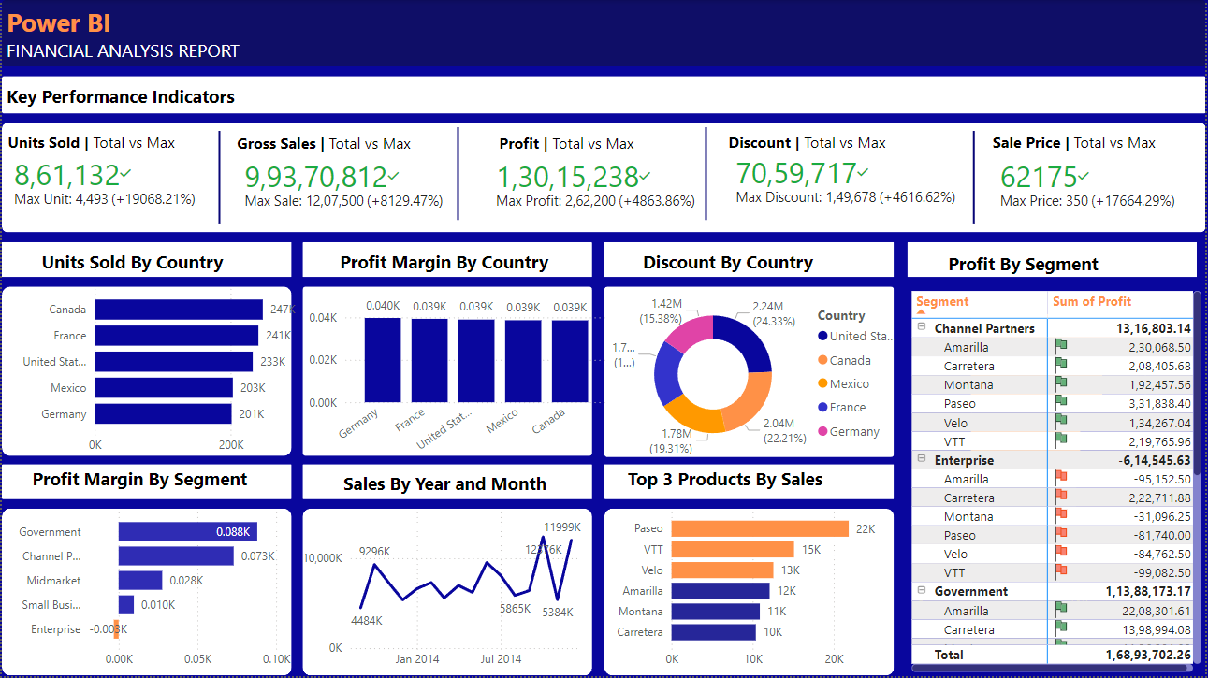

##### ****Visuals****:

1. **KPI Cards**:
   * Total Sales, Total Profit, Average Sales, and Profit Margin.
   * These cards provide a snapshot of critical metrics.
2. **Bar Chart**:
   * Sales by Category: Highlights which categories generate the most revenue.
3. **Line Chart**:
   * Sales Trend over Time: Displays monthly sales trends to identify peaks and dips.
4. **Slicer**:
   * Region and Year filters allow users to dynamically adjust the analysis.

##### ****Insights****:

* Total Sales exceeded $5M in the last fiscal year, with a 10% year-over-year growth.
* Electronics is the top-performing category, contributing 45% of total revenue.
* Sales peak during Q4, indicating strong seasonal demand.

##### ****Interactivity****:

* Slicers enable filtering by region and year.
* Clicking on a category in the bar chart cross-filters other visuals.

#### ****3.2 Page 2: Regional Analysis****

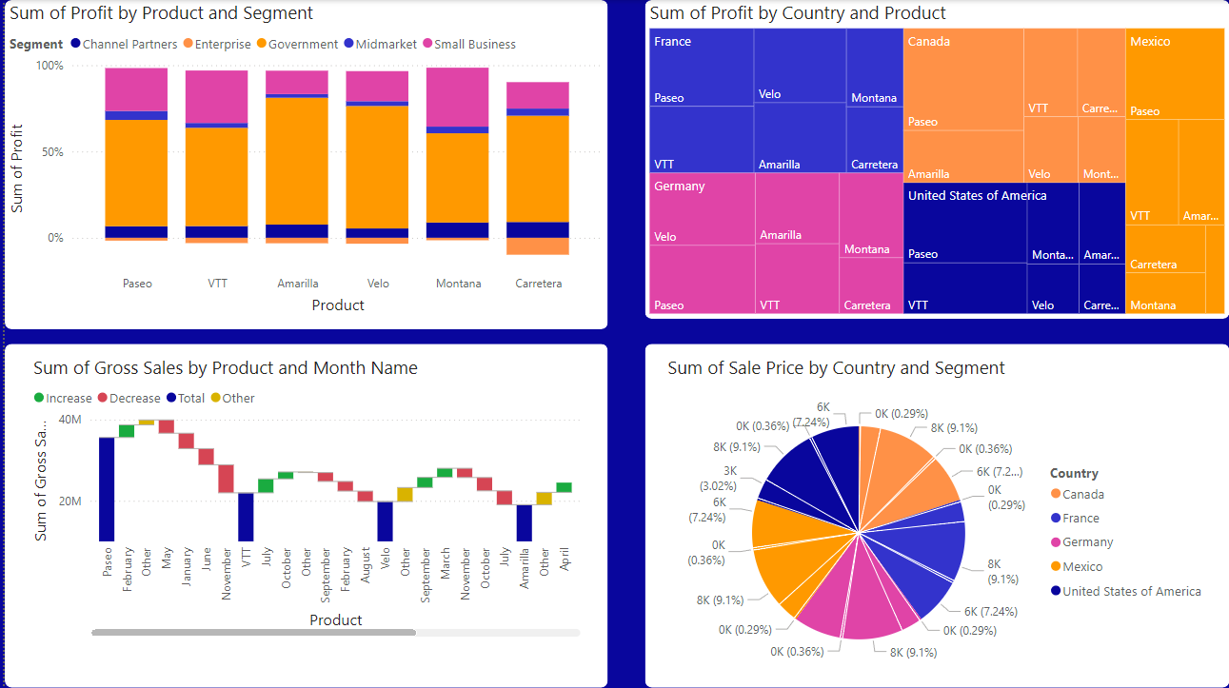

##### ****Visuals****:

1. **Map Visualization**:
   * Displays sales and profit distribution across regions.
   * Each bubble represents a region, with size proportional to sales and color indicating profit.
2. **Clustered Bar Chart**:
   * Profit by Region: Shows profit comparisons across regions.
3. **Pie Chart**:
   * Sales Contribution by Region: Highlights each region’s share of total sales.

##### ****Insights****:

* The East region generates the highest revenue but has a lower profit margin compared to the West.
* Central region underperforms, contributing only 15% to total sales.
* Opportunities for growth exist in the South region, which has a high profit margin but lower sales.

##### ****Interactivity****:

* Clicking on a region in the map filters the bar and pie charts to show region-specific data.

#### ****3.3 Additional Features****

* **Row-Level Security**: Describe if data visibility is restricted based on user roles.
* **Custom Hierarchies**: For example, drill-down options from Year → Quarter → Month.

### ****4. Conclusion****

The dashboard provides a comprehensive view of financial performance, highlighting trends, regional strengths, and areas for improvement. By leveraging interactive visualizations and dynamic filtering, it enables data-driven decision-making for sustained business growth.